Straight Edge
# Source: AI Source: Provided by: [Data Path: Persons Table -> ID Column: 1, Name_En Column: Motasem Essam] -> From: [ChatGPT] on [7/25/2026]
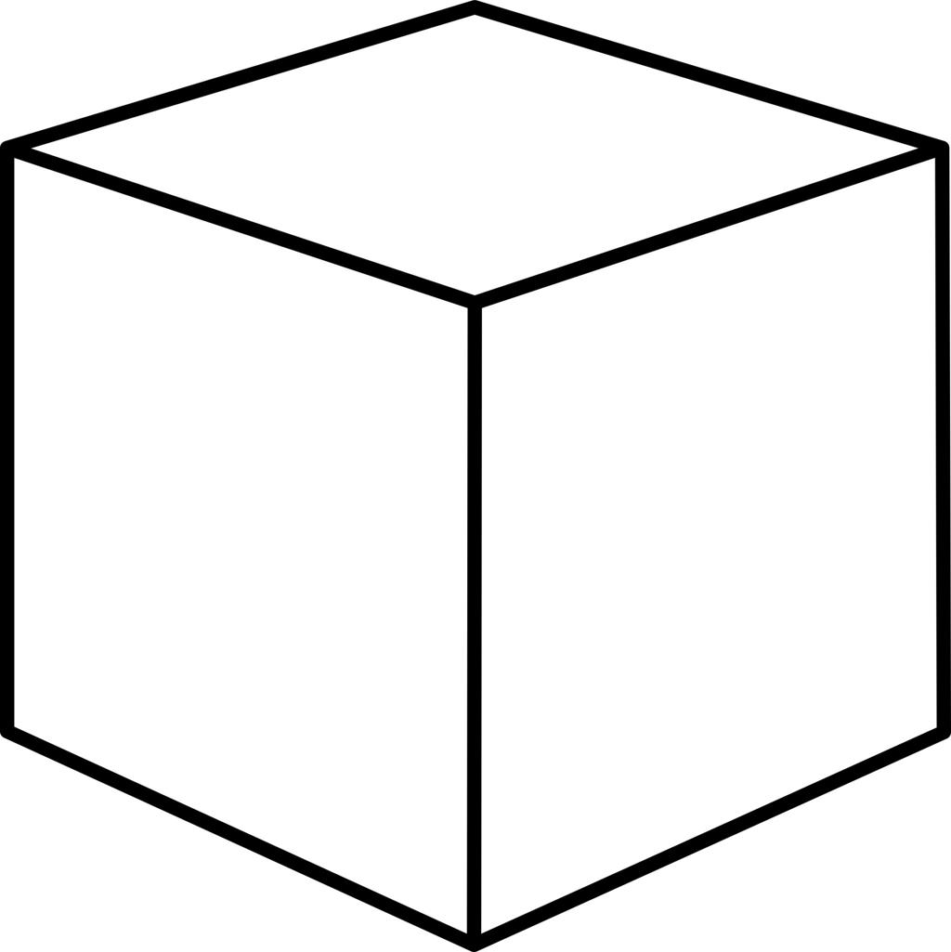
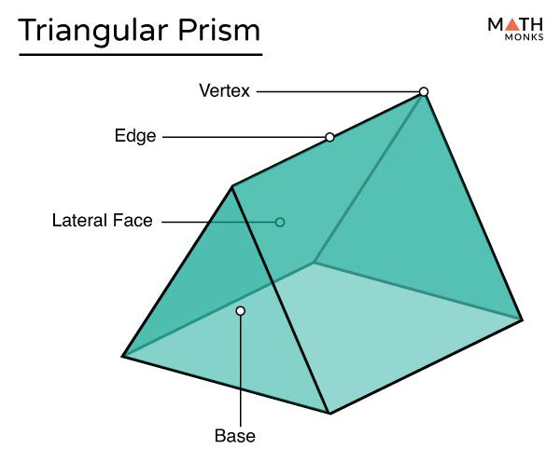
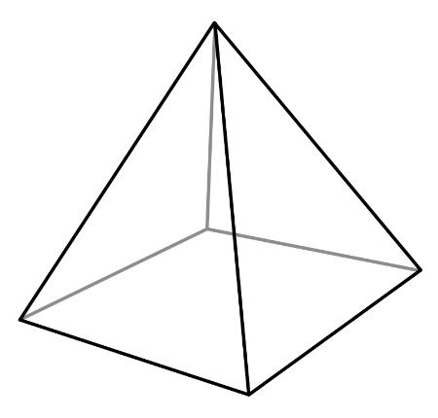

Definition
# Source: AI Source: Provided by: [Data Path: Persons Table -> ID Column: 1, Name_En Column: Motasem Essam] -> From: [ChatGPT] on [7/25/2026]
A straight edge in solid geometry is a straight line segment forming part of the boundary of a three-dimensional solid. It typically occurs where two flat faces of a polyhedron meet.
Straight edges connect vertices and define the outlines of faces. They are common in solids such as cubes, cuboids, prisms, and pyramids.
For example, every edge of a cube is a straight line segment joining two of its vertices.
Important distinction: In standard Euclidean geometry, the edges of a polyhedron are straight line segments. The term straight edge is especially useful when distinguishing these from curved boundaries or curved lines on other geometric surfaces.

Simple definition
# Source: AI Source: Provided by: [Data Path: Persons Table -> ID Column: 1, Name_En Column: Motasem Essam] -> From: [ChatGPT] on [7/25/2026]
A straight edge is a straight segment along a solid's boundary, usually where two flat faces meet.
Examples include:
- An edge of a cube.
- An edge of a triangular prism.
- An edge connecting the apex of a pyramid to a base vertex.

Classification tree
# Source: AI Source: Provided by: [Data Path: Persons Table -> ID Column: 1, Name_En Column: Motasem Essam] -> From: [ChatGPT] on [7/25/2026]
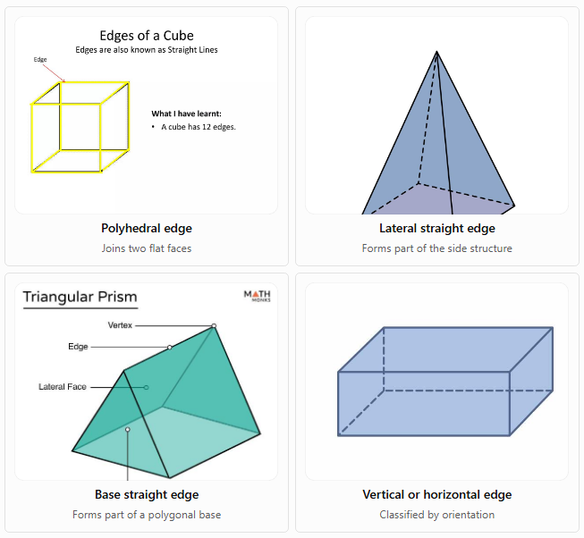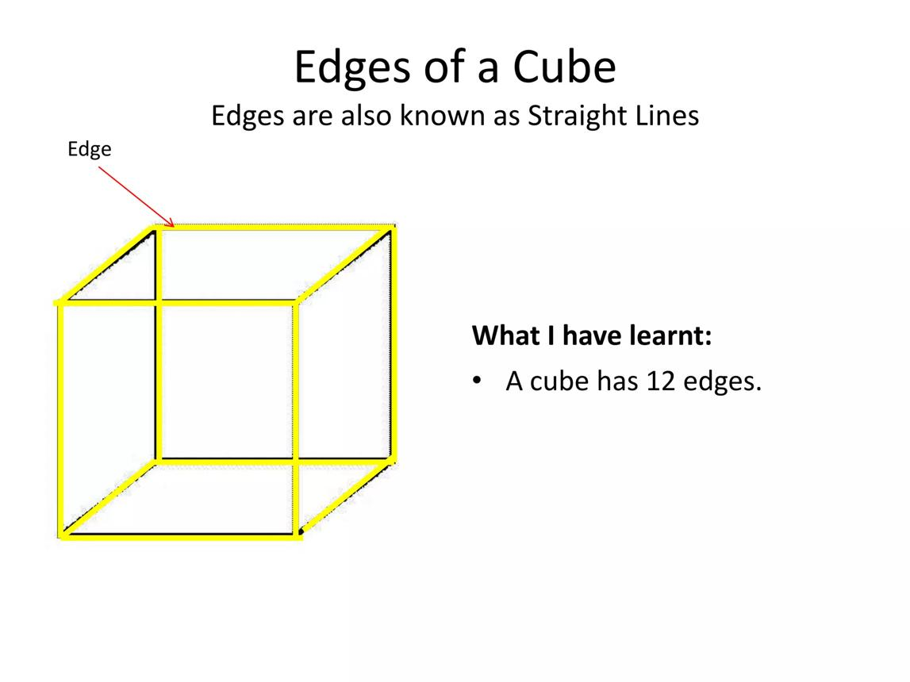
Polyhedral edge
Joins two flat faces
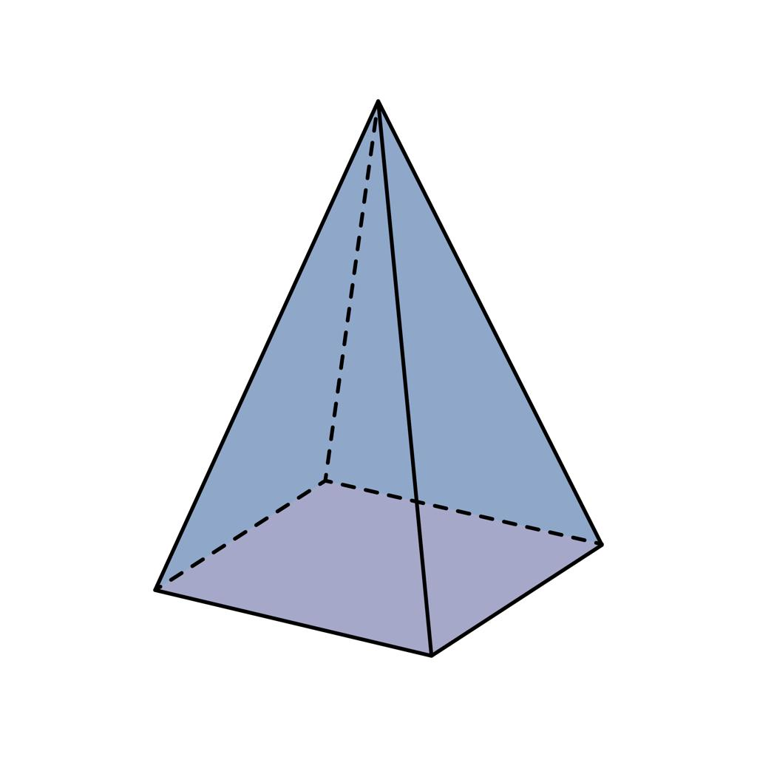
Lateral straight edge
Forms part of the side structure
Base straight edge
Forms part of a polygonal base
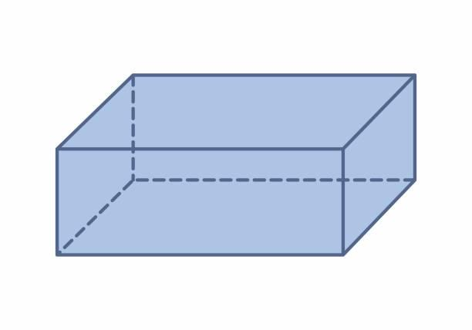
Vertical or horizontal edge
Classified by orientation
These labels describe different properties of straight edges. For example, one edge can be both straight and a base edge.

Key characteristics
# Source: AI Source: Provided by: [Data Path: Persons Table -> ID Column: 1, Name_En Column: Motasem Essam] -> From: [ChatGPT] on [7/25/2026]
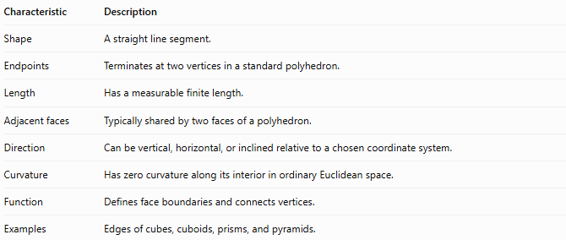
Characteristic | Description
Shape | A straight line segment.
Endpoints | Terminates at two vertices in a standard polyhedron.
Length | Has a measurable finite length.
Adjacent faces | Typically shared by two faces of a polyhedron.
Direction | Can be vertical, horizontal, or inclined relative to a chosen coordinate system.
Curvature | Has zero curvature along its interior in ordinary Euclidean space.
Function | Defines face boundaries and connects vertices.
Examples | Edges of cubes, cuboids, prisms, and pyramids.

Geometric representation
# Source: AI Source: Provided by: [Data Path: Persons Table -> ID Column: 1, Name_En Column: Motasem Essam] -> From: [ChatGPT] on [7/25/2026]
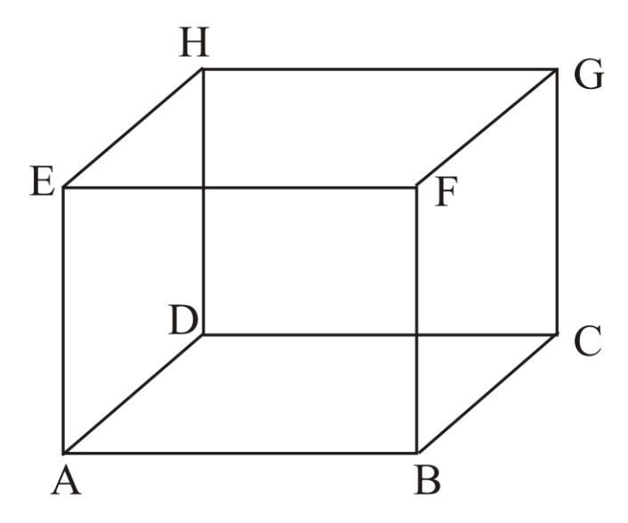
Consider a cube with vertices $A,B,C,D,E,F,G,H$.
Its edges are straight line segments, such as:
$$\overline{AB}, \overline{BC}, \overline{CD}, \overline{DA}$$
These four segments form the boundary of one square face.
A cube has 12 straight edges in total, and each edge is shared by two adjacent square faces.
Examples in other solids

A. Cuboid
# Source: AI Source: Provided by: [Data Path: Persons Table -> ID Column: 1, Name_En Column: Motasem Essam] -> From: [ChatGPT] on [7/25/2026]
A cuboid has 12 straight edges: four around the top face, four around the bottom face, and four connecting corresponding vertices.
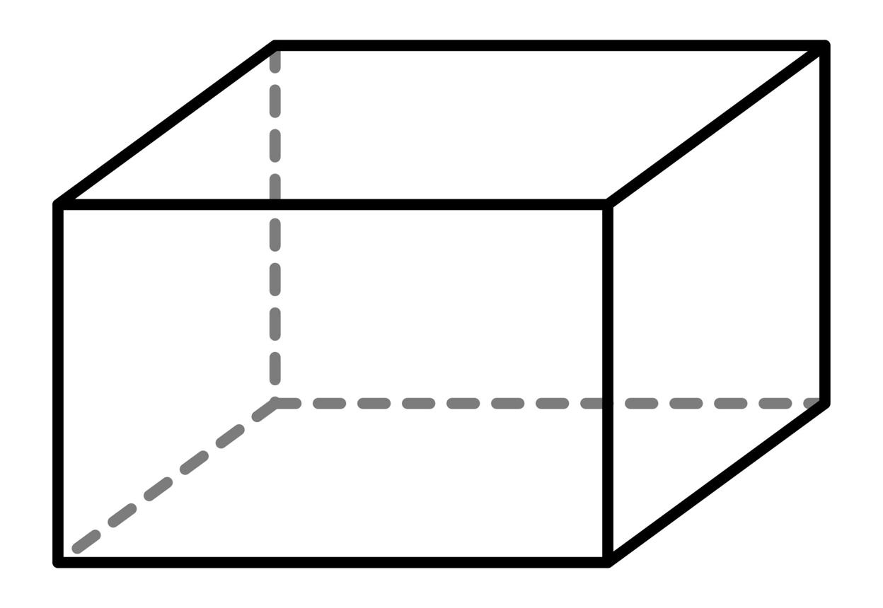

B. Triangular prism
# Source: AI Source: Provided by: [Data Path: Persons Table -> ID Column: 1, Name_En Column: Motasem Essam] -> From: [ChatGPT] on [7/25/2026]
A triangular prism has nine straight edges: three on each triangular base and three lateral edges.
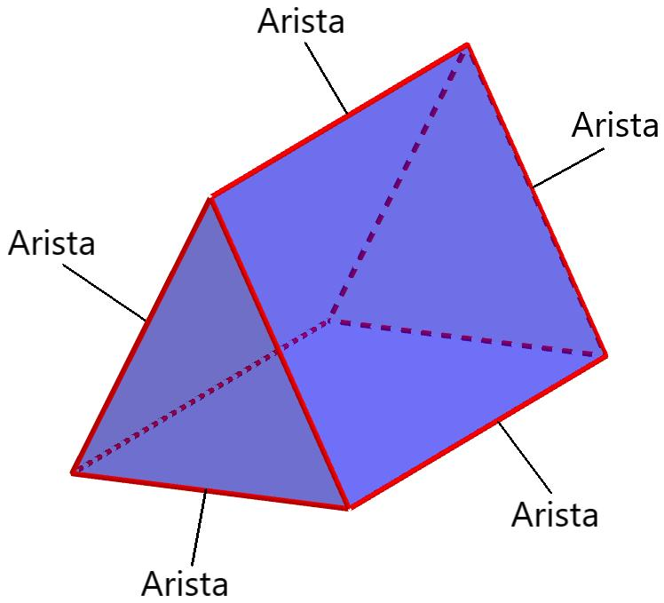

C. Square pyramid
# Source: AI Source: Provided by: [Data Path: Persons Table -> ID Column: 1, Name_En Column: Motasem Essam] -> From: [ChatGPT] on [7/25/2026]
A square pyramid has eight straight edges: four base edges and four lateral edges.
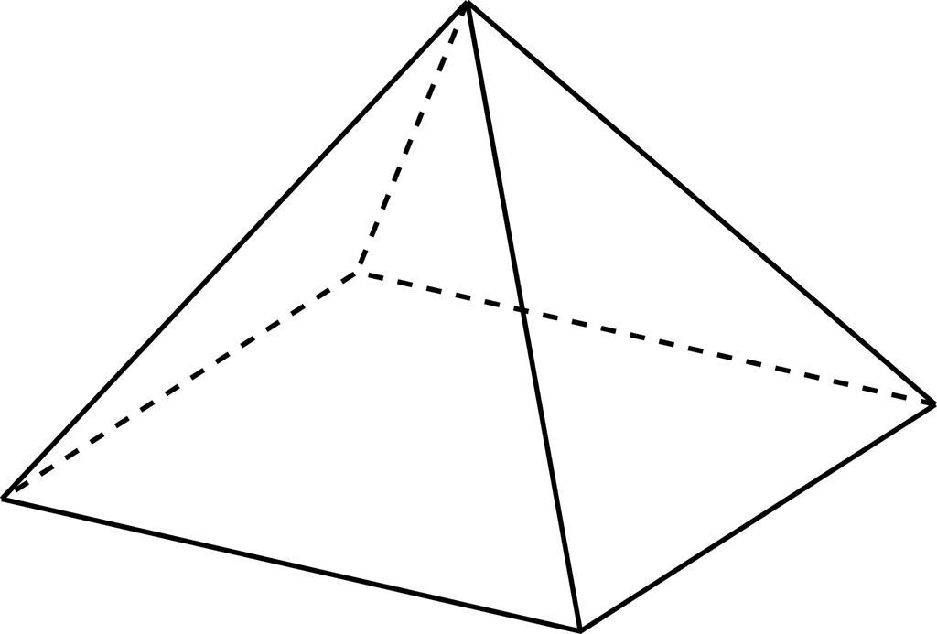

Mathematical representations

A. Length of a straight edge in three dimensions
# Source: AI Source: Provided by: [Data Path: Persons Table -> ID Column: 1, Name_En Column: Motasem Essam] -> From: [ChatGPT] on [7/25/2026]
Suppose a straight edge connects two points:
$$A=\left(x_{1},y_{1},z_{1}\right), B=\left(x_{2},y_{2},z_{2}\right).$$
Its length is calculated using the three-dimensional distance formula:
$$\boxed{L=\sqrt{{\left(x_{2}-x_{1}\right)}^{2}+{\left(y_{2}-y_{1}\right)}^{2}+{\left(z_{2}-z_{1}\right)}^{2}}}$$
This formula measures the straight-line distance between the two endpoints.

B. Straight edges of a cube
# Source: AI Source: Provided by: [Data Path: Persons Table -> ID Column: 1, Name_En Column: Motasem Essam] -> From: [ChatGPT] on [7/25/2026]
For a cube with side length $a$, every edge has length:
$$\boxed{L=a}$$
Since a cube has 12 edges, the sum of all edge lengths is:
$$\boxed{L_{\text{total}}=12a}$$

C. Number of edges in common solids
# Source: AI Source: Provided by: [Data Path: Persons Table -> ID Column: 1, Name_En Column: Motasem Essam] -> From: [ChatGPT] on [7/25/2026]
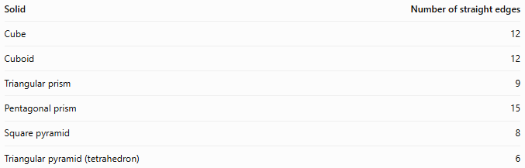
Solid | Number of straight edges
Cube | 12
Cuboid | 12
Triangular prism | 9
Pentagonal prism | 15
Square pyramid | 8
Triangular pyramid (tetrahedron) | 6
For a prism with an $n$-sided polygonal base:
$$\boxed{E=3n}$$
For a pyramid with an $n$-sided polygonal base:
$$\boxed{E=2n}$$
These formulas apply to ordinary prisms and pyramids with polygonal bases.

Worked examples
# Source: AI Source: Provided by: [Data Path: Persons Table -> ID Column: 1, Name_En Column: Motasem Essam] -> From: [ChatGPT] on [7/25/2026]
Example 1: Finding the length of a straight edge
An edge connects the points $A=\left(1,2,3\right)$ and $B=\left(4,6,3\right)$. Find its length.
Step 1: Apply the three-dimensional distance formula.
$$L=\sqrt{{\left(4-1\right)}^{2}+{\left(6-2\right)}^{2}+{\left(3-3\right)}^{2}}$$
Step 2: Simplify.
$$\begin{aligned}L&=\sqrt{3^{2}+4^{2}+0^{2}} \\ &=\sqrt{9+16} \\ &=\sqrt{25}\end{aligned}$$
Answer:
$$\boxed{L=5\text{ units}}$$
Example 2: Total edge length of a cube
A cube has an edge length of $6\text{ cm}$. Find the sum of the lengths of all its edges.
A cube has 12 edges.
$$L_{\text{total}}=12a$$
Substitute $a=6$:
$$L_{\text{total}}=12\left(6\right)=72\text{ cm}$$
Answer: The total length of all 12 edges is $\boxed{72\text{ cm}}$.
Example 3: Counting straight edges of a hexagonal prism
A hexagonal prism has a base with six sides. Determine its total number of straight edges.
For a prism:
$$E=3n$$
With $n=6$:
$$E=3\left(6\right)=18$$
Answer: A hexagonal prism has $\boxed{18}$ straight edges.

Comparison with related concepts
# Source: AI Source: Provided by: [Data Path: Persons Table -> ID Column: 1, Name_En Column: Motasem Essam] -> From: [ChatGPT] on [7/25/2026]
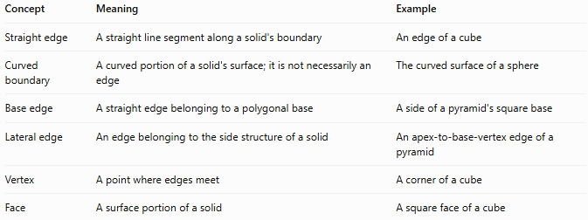
Concept | Meaning | Example
Straight edge | A straight line segment along a solid's boundary | An edge of a cube
Curved boundary | A curved portion of a solid's surface; it is not necessarily an edge | The curved surface of a sphere
Base edge | A straight edge belonging to a polygonal base | A side of a pyramid's square base
Lateral edge | An edge belonging to the side structure of a solid | An apex-to-base-vertex edge of a pyramid
Vertex | A point where edges meet | A corner of a cube
Face | A surface portion of a solid | A square face of a cube
Important: Straightness describes an edge's shape, while base and lateral describe its role in a solid. Therefore, a straight edge can simultaneously be a base edge or a lateral edge.

Applications
# Source: AI Source: Provided by: [Data Path: Persons Table -> ID Column: 1, Name_En Column: Motasem Essam] -> From: [ChatGPT] on [7/25/2026]
Straight edges are important in:
- Architecture: measuring beams, corners, and the edges of structural components.
- Engineering: defining the dimensions and connections of manufactured parts.
- Computer graphics: constructing polygon meshes from vertices and line segments.
- Technical drawing: representing the outlines of three-dimensional objects.
- Geometry: calculating edge lengths, counting edges, and analyzing polyhedra.
- Manufacturing: specifying lengths and dimensions for components with flat faces.

Key points
# Source: AI Source: Provided by: [Data Path: Persons Table -> ID Column: 1, Name_En Column: Motasem Essam] -> From: [ChatGPT] on [7/25/2026]
- A straight edge is a straight line segment on a solid's boundary.
- In polyhedra, edges generally connect vertices and separate adjacent faces.
- Cubes, cuboids, prisms, and pyramids have straight edges.
- The three-dimensional distance formula calculates the length of a straight edge from its endpoints.
- Straight, base, lateral, and vertical are different classifications that can overlap.
- A curved surface is not automatically a curved edge; the terms describe different geometric features.

Conclusion
# Source: AI Source: Provided by: [Data Path: Persons Table -> ID Column: 1, Name_En Column: Motasem Essam] -> From: [ChatGPT] on [7/25/2026]
A straight edge in solid geometry is a fundamental geometric feature that connects vertices and defines the boundaries of faces. Recognizing straight edges helps us understand the structure of polyhedra, calculate dimensions, and distinguish edges from faces, vertices, and curved surface portions.

